

**This Excel add-in allows you to add new ribbon “My Macro” with some extra features, like font cases, Indian number format, one click to add bulk sheet, one click to show all sheet, quick fill series, very hide sheets and some function like NUMTOWORD, SCORE, GETFUNCTION, GETNUMARI** **C, SPLIT etc.**

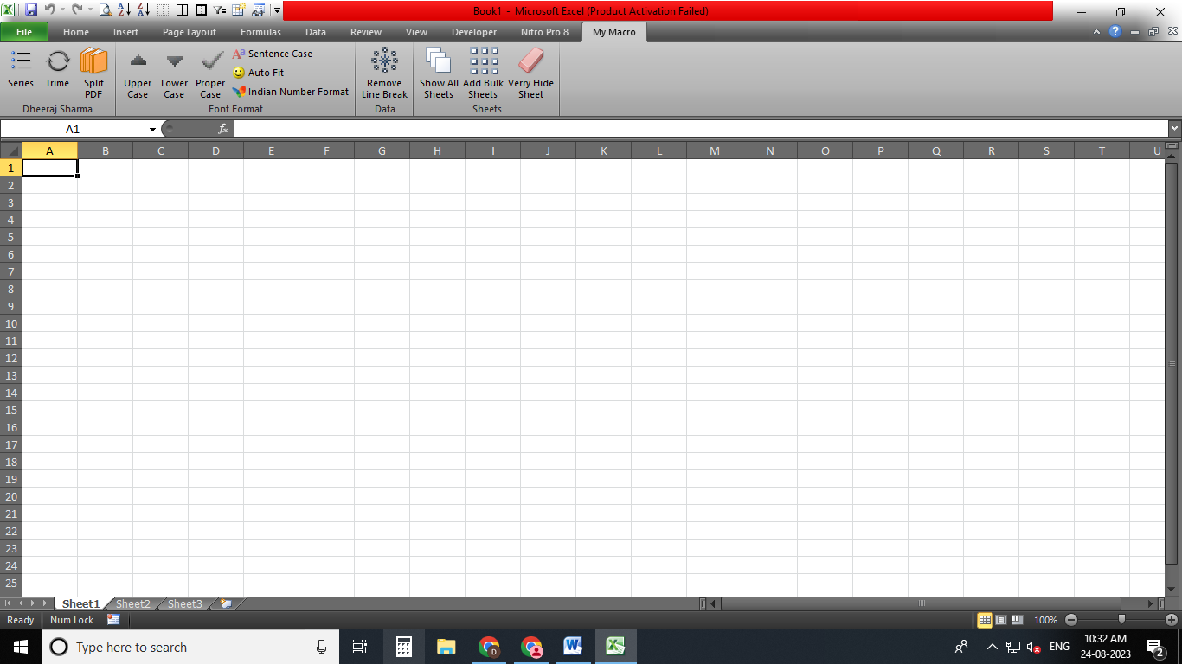**Note : don’t panic to any error we are always ready to your help.**

This is my macro tab with some features

**How to uninstall**

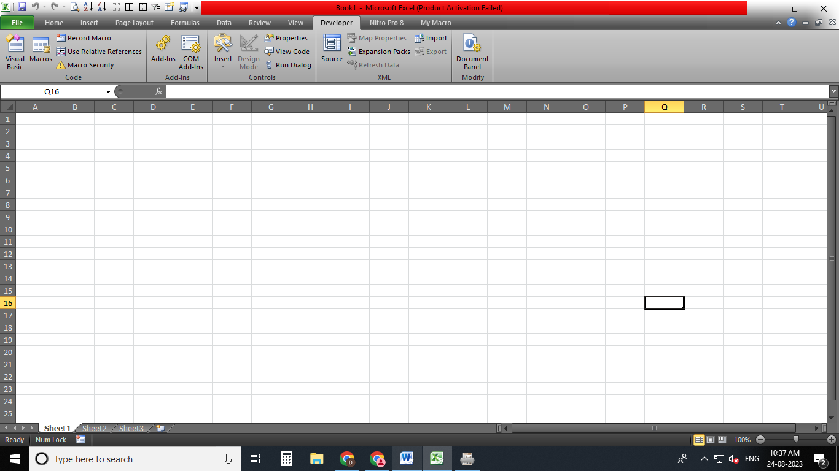**1st Go To Developer Tab**

**2nd Click to Add-Ins**

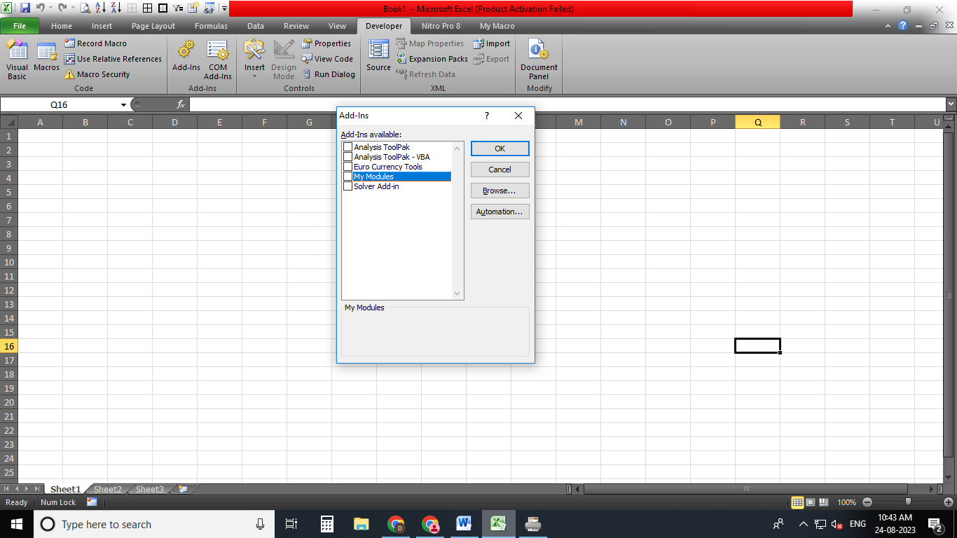 **3rd Unchecked My Modules then click ok.**

**4th Go To File > Option >** **Customize Ribbon, then click Reset and click**

**“Reset all customizations”**

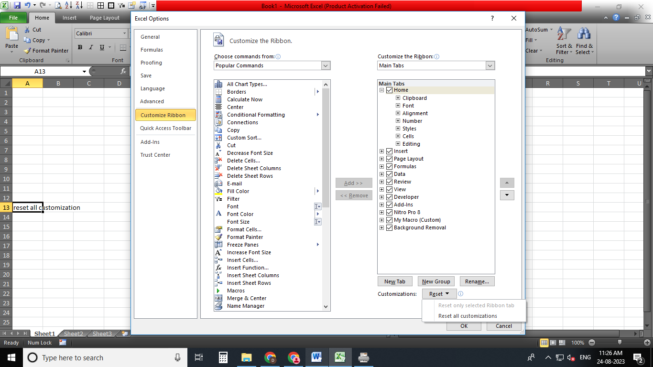

**4th Press F12 then Select Save as type “Excel Add-In” then copy this path and then close all files and folders.**

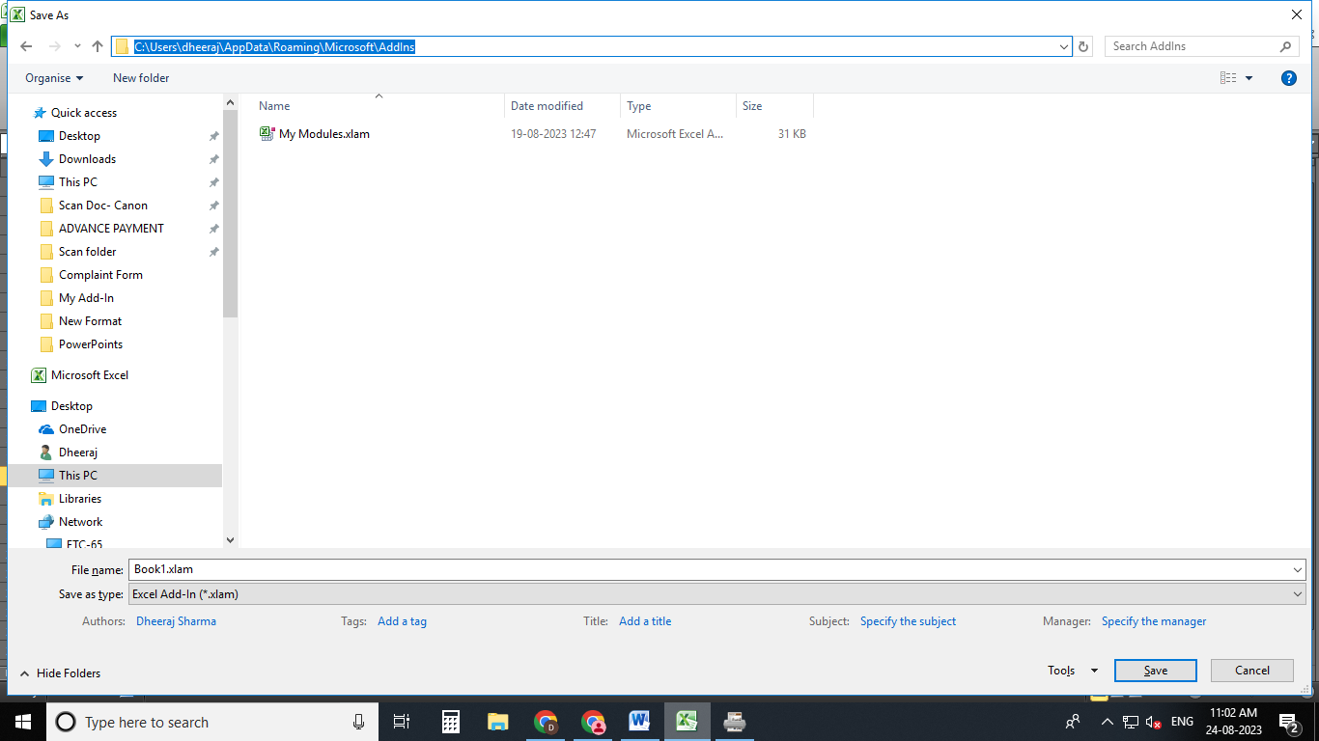

**5th Open windows file explorer then past path here and hit Enter.**

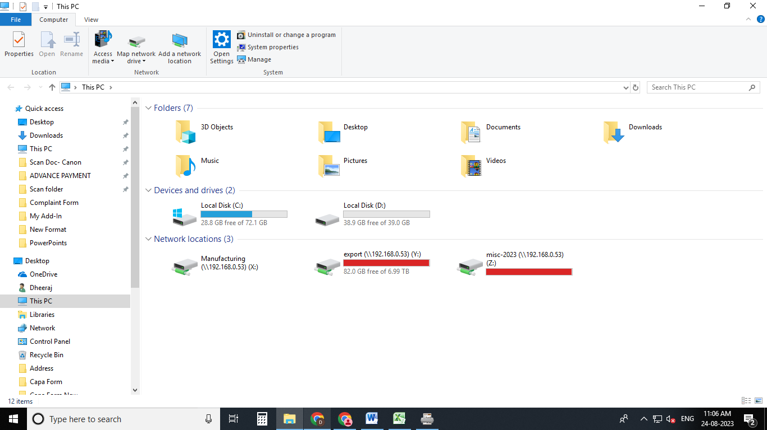

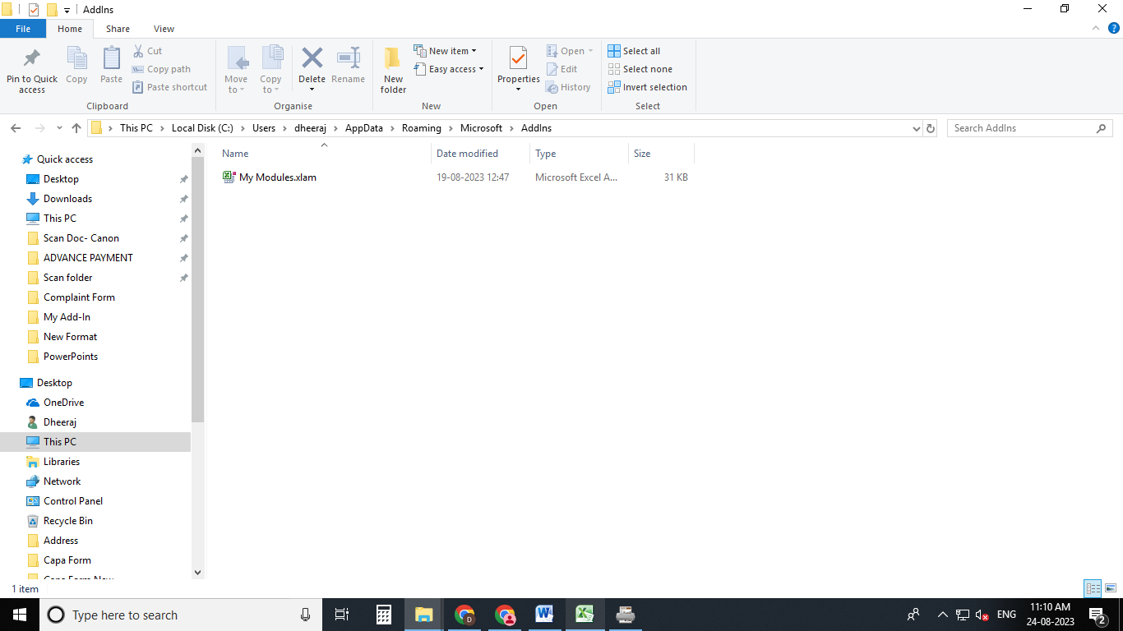**6th Delete This File, after deleting the file the uninstallation process will be completed.**

**Please subscribe my YouTube channel**

**My Helpdesk**

<https://www.youtube.com/channel/UCgskQN2gSwzVjJ4k05vnc6Q?sub_confirmation=1>